What to do
IMPORTANT Parent or Carer –
Please check that you are happy with any weblinks or use of the internet.

1. Read a poem

Share and read together to enjoy I really want to be a cat. Pause to discuss it as you read. Read it again, thinking about all the reasons that it would be so cool to be a cat!

2. Write your own poem

- Talk about being a dog. Would it be fun to be a dog? Brainstorm ideas about what you could get up to if you were a dog.
  - I could run faster than any person!
  - I could jump over fences or walls.
- Now look at the poem sheet I really want to be a dog, and discuss which things we might write to create our poem.
- Together, with your child writing some parts and you writing other parts from their dictation, write a poem about being a dog.

NB. Getting young children to write is not easy!
See Guidance and handwriting groups below.

Try these Fun-Time Extras

- Read the poem Can you walk on tip-toe? Try out all the ways of moving.
- Watch these funny cat videos! Or research your own.
https://www.youtube.com/watch?v=i09cua9QN7I

I really want to be a cat

I really want to be a cat,
what’s so very wrong with that?

I want to scratch and slink and prowl
but all I do is bark and growl.
I want to chase the birds and mice -
I know it isn’t very nice!

I want to jump upon the table
to steal some food when I am able.
I want to climb the highest tree
but solid ground is all I see.

I want to purr and go meow,
the problem is I don’t know how!
I want to prowl around at night
but all I do is get a fright.

I really want to be a cat,
what’s so very wrong with that?
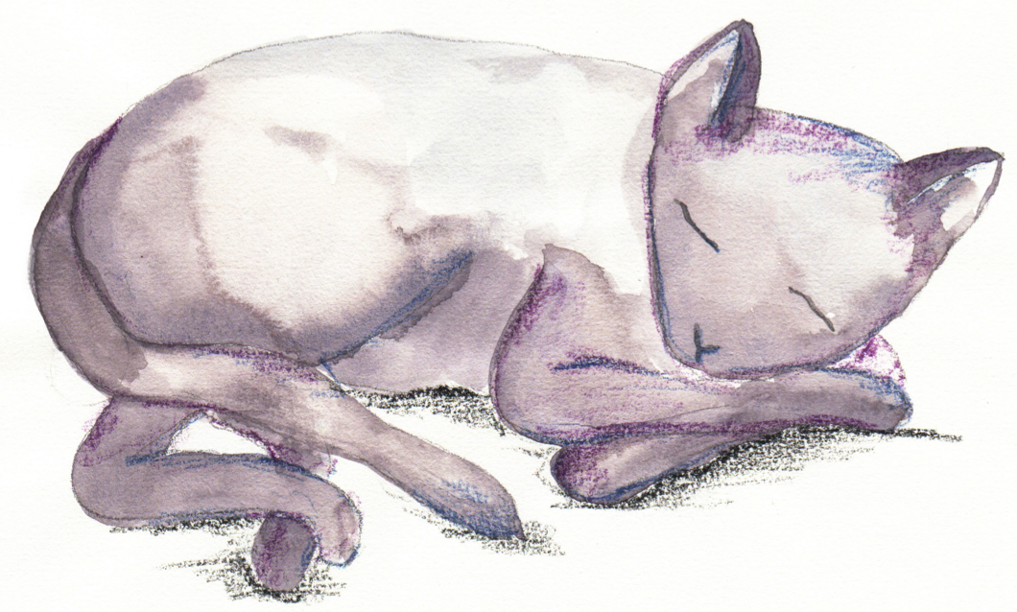
I really want to be a dog

I really want to be a dog

I really want to _________________________

I know it isn’t very nice!

I really want to _________________________

But _________________________________

I really want to _________________________

I really want to
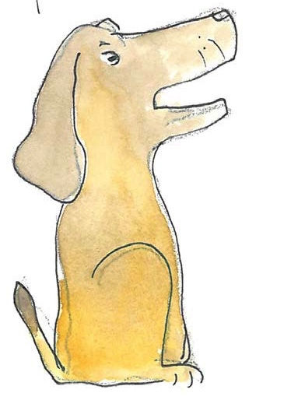
_________________________

What’s so very wrong with that?

Can you walk on tip-toe?

Can you walk on tip-toe
As softly as a cat?
And can you stamp along the road,
Stamp, stamp just like that?

Can you take some great big strides
Just like a giant can?
Or walk along so slowly
Like a poor crooked man?

Can you squeak so softly
As gently as a mouse?
And can you roar so boldly
Like a lion in the house?

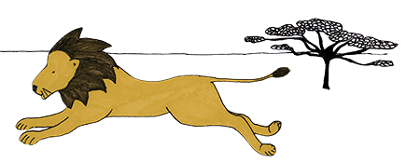
Guidance for writing – some do’s and don’ts

- DO focus on letter formation. See sheet below. It’s really important that children get into the habit of writing letters correctly – this is not about how the finished letter looks, it’s all about how they write it – what direction they move the pencil or pen. Bad habits are almost impossible to break – if they form letters wrongly, the finished letter may look good BUT in the long run, they are much less likely to be able to write fluently.

- DON’T write a word or a line for them to copy. If they can’t remember how to write a letter, demonstrate, forming it correctly, so that they can imitate you.

- DO give loads of praise. Writing is so hard, and children get discouraged easily. It may be that they have just written one or two words, but if you praise them, it may be four words next time!

- DON’T do ‘dotty’ letters for them to trace. It is much better for children to form their own letters. We are teaching them to write not trace!

- DO write for them sometimes. It is important that young children can express their ideas in written form, and sometimes it is really good to write down what they say so that their ideas are expressed in writing on the page. Sometimes you can take turns to scribe. You write a bit, then they write a bit.
Handwriting Letter Groups

There are basically 4 groups of letters – in terms of how we move the pen to write these.

- Long Ladder Letters: Start at the top and go down and then off in another direction, e.g. i, j, l, t, u

- Bouncing Ball Letters: Start at the top, and go down and retrace upwards, e.g. b, h, k, m, n, p, r

- Curly Caterpillar Letters: Start at the top and go anti-clockwise round, e.g. c, a, d, e, g, o, q, f, s

- Zigzag letters: Zigzag from top then down, e.g. v, w, x, z

Scroll on down ….

Letter Groups

Group 1 – Long Ladder Letters  Start at the top and come down the ladder and go off into another direction.  i j l  t u | Group 2 – Bouncing Ball Letters  Start at the top, go down and then re-trace upwards.  b h k  m n p r
Group 3 – Curly Caterpillar Letters  Start at the top and go anti-clockwise round.  c a d e g o q f s | Group 4 – Zigzag Letters  Start at the top and zigzag down and up again.  v w x z

